Project-Phase 1
  - Deadline: Day 26/07/2026 @ 23:59
[Total Mark is 5]

Computer Networks
CS360

Student Details: CRN: 50243
Name: Abdulrahman Bin Omran  Name: Abdullah Ali Almekrami  Name: Ali Zaid Almogherah |  | ID: 240005185  ID: 240004954  ID: 200068392

Instructions:
- You must submit two separate copies (one Word file and one PDF file) using the Assignment Template on Blackboard via the allocated folder. These files must not be in compressed format.
- It is your responsibility to check and make sure that you have uploaded both the correct files.
- Zero mark will be given if you try to bypass the SafeAssign (e.g., misspell words, remove spaces between words, hide characters, use different character sets, convert text into image or languages other than English or any kind of manipulation).
- Email submission will not be accepted.
- You are advised to make your work clear and well-presented. This includes filling your information on the cover page.
- You must use this template, failing which will result in zero mark.
- You MUST show all your work, and text must not be converted into an image, unless specified otherwise by the question.
- Late submission will result in ZERO mark.
- The work should be your own, copying from students or other resources will result in ZERO mark.
- Use Times New Roman font for all your answers.

Project Instruction
Project Objective:
Design, configure, and test a network setup in Packet Tracer to successfully transmit data packets between devices in different LANs across two separate WANs (WAN 1 and WAN 2).
Group Details
- Group Size = Maximum of 3 Members.
- One group member (group leader/coordinator) must submit the project report on blackboard. Marks will be given based on your submission and quality of the contents.
Project Report
- The project is divided into two phases:
  - Phase 1 (Mid project Progress Report)
  - Phase 2 (Final project Report)
- This report is for Phase 1. In this report, you should complete all the requirements for Phase 1 only.
- Each Report will be evaluated according to the marking criteria

Project Description (Common to Phase 1 and Phase 2)
Learning Outcome(s):
Demonstrate protocol configuration, network-addressing schemes and analyze packet transmission for the Local and Wide Area Networks.

A university operates two campuses: a Main Campus and a Branch Campus. Each campus network is treated as a separate WAN site. Your task is to design and configure, in Cisco Packet Tracer, a network that successfully transmits data packets from a device in any LAN of WAN 1 (Main Campus) to a device in any LAN of WAN 2 (Branch Campus). Each WAN contains 2 LANs, and each LAN has 3 end devices.

Network Design Requirements:
- WAN 1 (Main Campus):
  - Contains LAN 1 (Computer Lab) and LAN 2 (Admin Office).
  - Each LAN has 3 devices (PCs or laptops) connected through a switch.
  - Assign private IP addresses to the devices in each LAN (e.g., use 172.16.10.0/24 for LAN 1 and 172.16.20.0/24 for LAN 2).
  - Connect each LAN to a router (Router 1).
- WAN 2 (Branch Campus):
  - Contains LAN 3 (Library) and LAN 4 (Faculty Office).
  - Each LAN has 3 devices (PCs or laptops) connected through a switch.
  - Assign private IP addresses to the devices in each LAN (e.g., use 172.16.30.0/24 for LAN 3 and 172.16.40.0/24 for LAN 4).
  - Connect each LAN to a router (Router 2).
- WAN Connection:
  - Connect Router 1 and Router 2 using a serial link to simulate a WAN connection.
  - Assign IP addresses to the serial interfaces (e.g., 10.10.10.1/30 for Router 1 and 10.10.10.2/30 for Router 2).

Configuration Details:
- Assign IP Addresses:
  - Configure IP addresses, subnet masks, and default gateways for all devices in each LAN. Example:
    - LAN 1: 172.16.10.0/24, Default Gateway: 172.16.10.1 (Router 1's interface).
    - LAN 2: 172.16.20.0/24, Default Gateway: 172.16.20.1 (Router 1's interface).
    - LAN 3: 172.16.30.0/24, Default Gateway: 172.16.30.1 (Router 2's interface).
    - LAN 4: 172.16.40.0/24, Default Gateway: 172.16.40.1 (Router 2's interface).
- Router Configuration:
  - Configure IP addresses on the LAN and WAN interfaces of both routers. Example:
    - Router 1:
      - LAN 1 Interface: 172.16.10.1/24
      - LAN 2 Interface: 172.16.20.1/24
      - WAN Interface (Serial): 10.10.10.1/30
    - Router 2:
      - LAN 3 Interface: 172.16.30.1/24
      - LAN 4 Interface: 172.16.40.1/24
      - WAN Interface (Serial): 10.10.10.2/30
- Enable Routing:
  - Configure static routes or a dynamic routing protocol (e.g., RIP) on both routers to ensure communication between WAN 1 and WAN 2.

Phase 1 Requirements
5 Marks
Students are required to submit a short mid progress report, which must include the following:
- Work completed this period (2 marks): This includes the installation of Cisco Packet Tracer, and a study of Packet Tracer for creating nodes, using different types of links (copper straight-through, copper cross-over, serial DCE/DTE), and assigning IP addresses.
  - Note: You must show a screenshot of the installation of Packet Tracer (with your system visible, e.g., date/time or username). (1 mark)
  - Give a description of the objectives and advantages of using Packet Tracer for this project. (1 mark)
- One key decision made during this period (1 mark): For example, your choice of IP addressing scheme, choice of routing method to study, or division of work among group members. Explain briefly why the decision was made.
- One problem encountered (1 mark): Describe one genuine problem faced so far (technical or organizational) and its current status (resolved / in progress).
- Plan for the next period (0.5 mark): Briefly list the tasks you plan to complete before the final submission (e.g., building the topology, configuring routers, testing with ping).
- Each group member's input/participation (0.5 mark): State each member's name and their specific contribution during this period.

Version History / Commit Log Requirements (Common to Both Reports)
Students must document and submit their project history/timestamps using a live, editable link:
- Written report: Submit a shared Google Doc or Word Online link (sharing set to "Anyone with the link can view") along with your final PDF report. The link must show the progress of the students' work with timestamps/screenshots.
- Code/data/configuration files: Submit Packet Tracer files (.pkt) and any configuration scripts via a GitHub or GitLab repository link (the coordinator may choose a repository suitable for the course). The repository must show a commit history reflecting incremental progress. Commit regularly (at minimum once per week), with clear, descriptive commit messages.
A separate section in the report must be added and named "Project Artifacts" to include all links, for example:
  - Live report document (with edit history): [link]
  - GitHub/GitLab repository (with commit history): [link]
  - Packet Tracer project file (.pkt): [link or attached]
What NOT to do: Students must not write their report elsewhere and paste the final version in at the last minute. They also must not make a single commit containing the entire project. Both are treated as red flags regardless of the quality of the final work.

Important Notes
- AI use: Students may use AI tools (ChatGPT, Claude, Copilot, Gemini, etc.) only for brainstorming approaches, debugging small errors, or proofreading text. AI must not be used to generate analysis, write configuration logic, or produce substantial portions of the report or project files. Any permitted AI use must be disclosed in the Reflection section. Undisclosed AI use, or AI use beyond this scope (disclosed or not), will result in a zero grade for the entire project.
- Any submission lacking a valid, inspectable version/commit history, or showing evidence of AI generation or plagiarism, will receive a zero grade for the entire project.
- Failure to submit the mid progress report as required, or submission of reports found to be fabricated, copied, or AI-generated, will result in a zero grade for the entire project.
- The mid progress report should be concise including screenshots.
- The same shared document link and repository submitted in Phase 1 must continue to be used for Phase 2, so that the full project history is visible in one place.

Project Artifacts:
  - Live report document: CS360_Project-Phase 1.docx
  - GitHub/GitLab repository : CS360_Project GitHub
  - Packet Tracer project file (.pkt): Packet Tracer Files

Work completed this period:
During the first phase, we prepared the project environment and created a GitHub repository to store the Packet Tracer files, screenshots, and project documents. A README file was created containing the group members’ names, student IDs, and GitHub usernames. We also decided to use the original project Word template as our shared report document to maintain the required format and record the group’s progress through the document history.
We installed Cisco Packet Tracer and became familiar with its interface and basic networking tools. We learned how to add and configure network devices such as PCs, laptops, switches, and routers and organize them into a network topology.
We also studied the different types of network connections available in Packet Tracer. We practiced using copper straight-through cables to connect end devices to switches and switches to routers. In addition, we learned the purposes of copper cross-over cables and Serial DCE/DTE cables.
We built the two required WAN topologies separately, with each WAN containing two LANs. WAN 1 includes LAN 1 (Computer Lab) and LAN 2 (Admin Office), while WAN 2 includes LAN 3 (Library) and LAN 4 (Faculty Office). We assigned static IP addresses, subnet masks, and default gateways to the end devices. We also configured the router interfaces with IP addresses that serve as the default gateways for their connected LANs.
Finally, we tested network communication using the ping command. The tests confirmed successful communication within each LAN and between the two LANs in each WAN.
Objectives and Advantages of Using Cisco Packet Tracer:
The main objective of using Cisco Packet Tracer in this project is to design, configure, and test the required network virtually. It allows us to build two WANs, each containing two LANs, connect the different network devices, assign IP addresses, configure routers, and test whether data packets can be transmitted successfully between devices in different LANs.
Packet Tracer provides several advantages for this project. It allows us to practice network configuration without using physical equipment, which reduces cost and saves time. It also provides a safe environment to test different configurations, identify and correct mistakes, and verify connectivity using the ping command. This helps us understand how end devices, switches, routers, network links, and IP addressing work together.
One key decision made during this period:
One key decision made during this period was to build and test WAN 1 and WAN 2 separately before combining them. This allowed the group members to work on different parts of the project at the same time. It also made it easier to identify and correct addressing or connectivity problems. After each WAN was successfully tested using the ping command, we planned to combine them and configure the connection between the two routers during the next phase.

One problem encountered:
One problem encountered was that two group members initially did not have GitHub accounts. This delayed adding them as collaborators and sharing the project files through the repository. The problem was resolved after both members created accounts, shared their usernames, joined the repository, and became familiar with the basic GitHub workflow.
Plan for the next period:
During the next period, we plan to combine the completed WAN 1 and WAN 2 topologies into one Packet Tracer file. We will connect Router 1 and Router 2 using a Serial DCE/DTE link and configure the serial interfaces with the required IP addresses. We will then configure static routes to enable communication between the two WANs. Finally, we will test communication between devices in all four LANs using the ping command, resolve any problems found, and document the final results for Phase 2.

Each group member’s input and participation:
Abdulrahman Bin Omran:
Week 1:
Discussed the project with the group and the distribution of the project tasks. Created the GitHub repository, organized the initial folders, created and edited the README file, added the students’ names, IDs, and GitHub usernames, and shared the project report document with the group.
Week 2:
Downloaded Cisco Packet Tracer and became familiar with the software.
Week 3:
Created the initial LAN 1 and LAN 3 topologies, tested connectivity between devices within each LAN using the ping command and coordinated the workflow among the group members.

Abdullah Ali Almekrami:
Week 1:
Planned the network topology with the team and discussed the IP addressing scheme for each LAN. Participated in reviewing the project requirements and helped organize the task distribution among the group members to ensure the work was completed efficiently.

Week 2:
Installed Cisco Packet Tracer, created a GitHub account, and prepared the required tools for the project.
Week 3:
Completed the WAN 1 network configuration and verified connectivity using ping tests.

Ali Zaid Almogherah:
Week 1:
During the first week, our team reviewed the project requirements, discussed the assignment guidelines, and outlined the overall network design. We also assigned tasks to each member according to their role to keep the project well organized and on schedule.
Additionally, I created a GitHub account, shared my username with the team, joined the project repository, and obtained access to the shared project report.
Week 2:
Downloaded Cisco Packet Tracer verified it was installed and working correctly and becoming familiar with the program.
Week 3:
Completed the WAN 2 (LAN 3 and LAN 4) configuration and verified network connectivity using ping tests.

Screenshot of the Installation of Packet Tracer:
Abdullah’s:
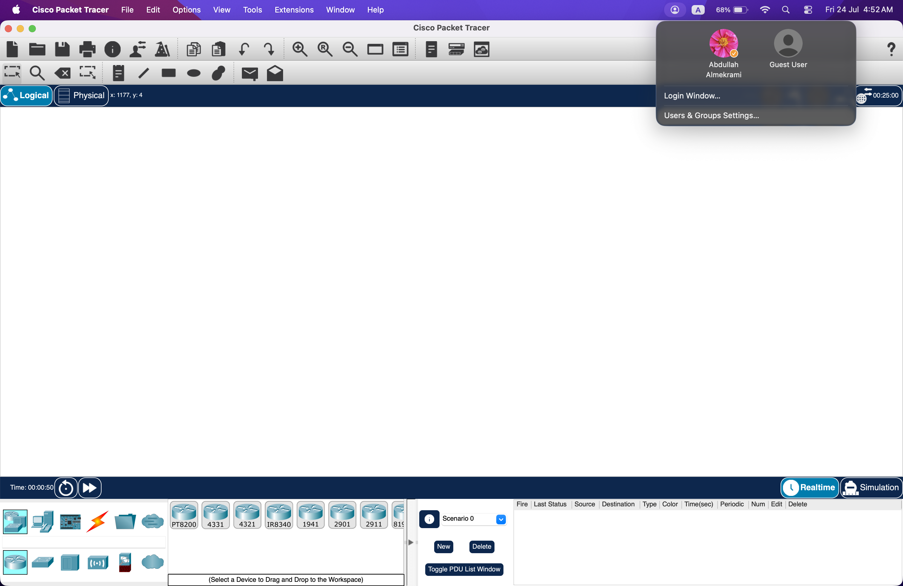
Abdulrahman’s:
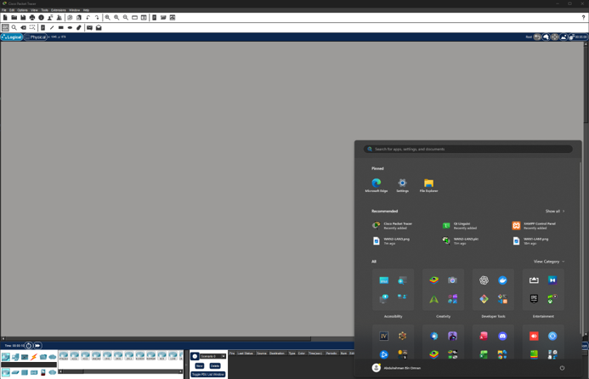
Ali’s:
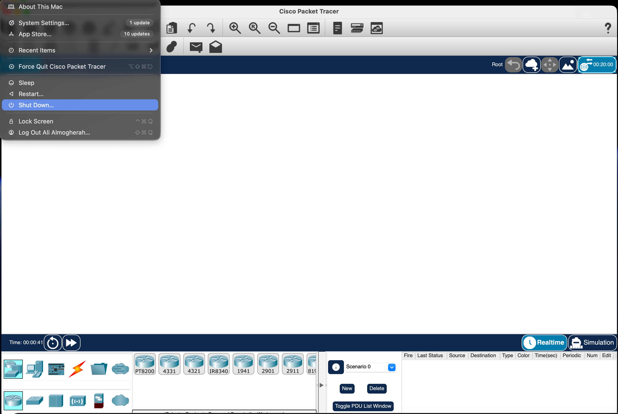

Reflection:
AI disclosure:
AI tools were used to brainstorm ideas, proofread the report for grammar and clarity, and help with the project review. All Packet Tracer configurations, connectivity tests, screenshots, and final decisions were completed and verified by the group members.

